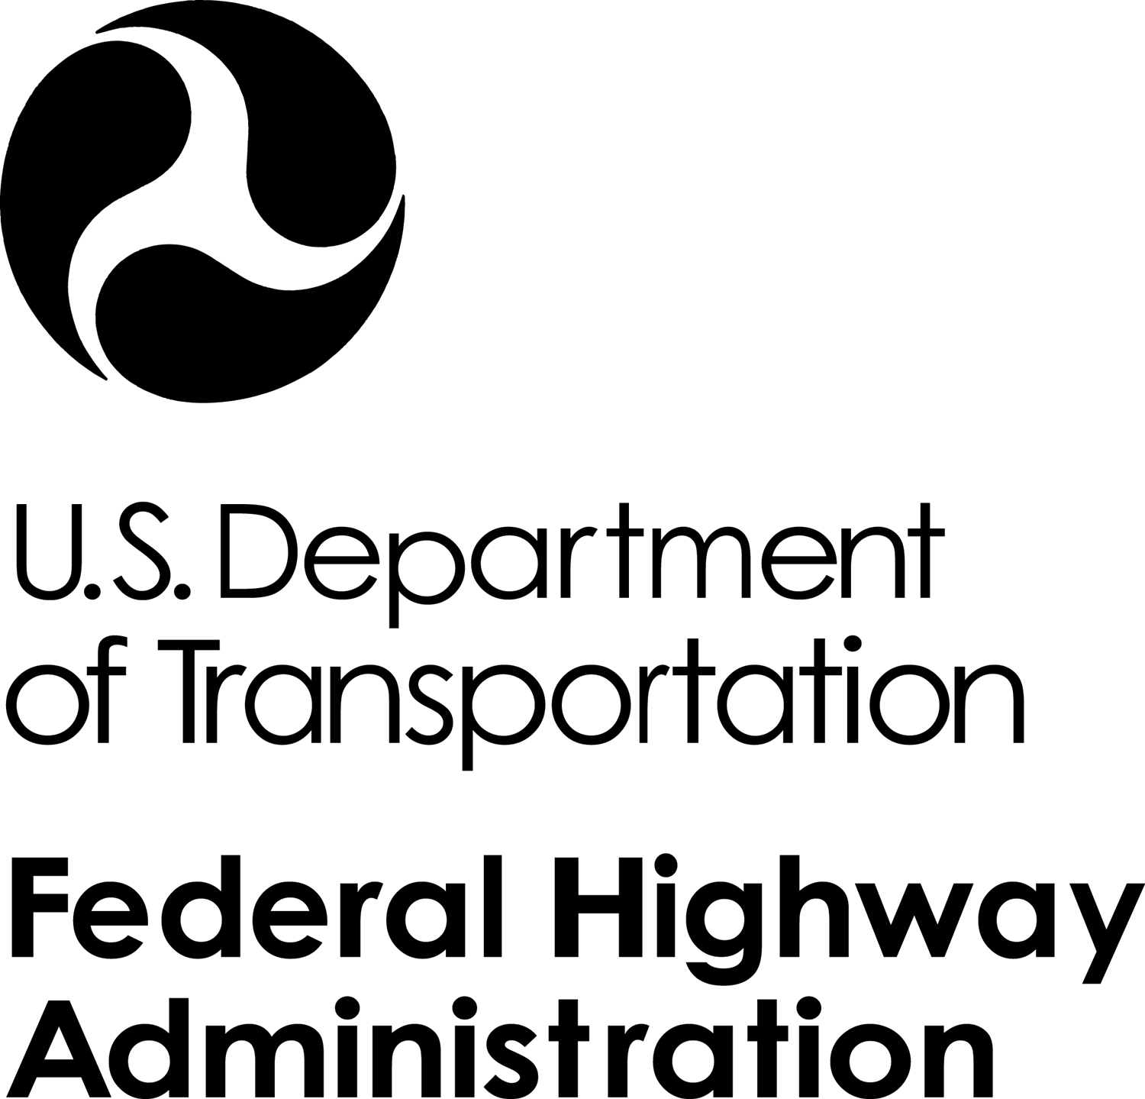

Memorandum

Date: date
Subject: Request for Brand Name or Equal Approval
Project Number Project Name
In Reply Refer To:
HFPM-16

From: Name
Project Manager

To: Mark Meng, Contracting Officer

We are hereby requesting authorization to use a brand name product for the above referenced project. The requested product will be used according to FP-14 Section ??? – Section Title, Item xxxxx-xxxx pay item description. A brief narrative describing the history and reasoning behind this request is included below.

Federal Acquisition Regulations (FAR) Subpart 11.104 Use of band name or equal purchase descriptions, states:

(a) While the use of performance specifications is preferred to encourage offerors to propose innovative solutions, the use of brand name or equal purchase descriptions may be advantageous under certain circumstances.

(b) Brand name or equal purchase descriptions must include, in addition to the brand name, a general description of those salient physical, functional, or performance characteristics of the brand name item that an "equal" item must meet to be acceptable for award. Use brand name or equal descriptions when the salient characteristics are firm requirements

In conformance with FAR Subpart 11.104, I submit the following information:

Narrative: [Describe why the specific product is needed. What are the properties of the product that make it so you can’t use a different product?]

Product Name: Product Name

Manufactured by: Company Name
Address Line 1
Address Line 2
Phone: Phone Number
Fax: Fax Number
Email: Website Address

SIGNATURES

Pursuant to FAR Subpart 11.104:

Requested by: Date:_____________
Name
Project Manager

Approved by: _____________________________ Date:_____________
Name
Contracting Officer

